**ITIS 6120 – APPLIED DATABASES**

**SPRING 2017**

**Hospital Management**

Alekhya Akkinepally

CONTENTS

1.Description of the Project

2.Objectives of the system

3.Scope

4.Use Cases

5.Database Design

* UML Diagram
* ER Diagram
* Tables
* Store Procedures
* User Authentication
* Views
* Triggers
* Indexes

6.Conclusion

7.Future Enhancements

8. References

**1.Description of the Project:**

Hospital are the essential part of our lives, providing best medical facilities to people suffering from various ailments, which may be due to change in climatic conditions, increased workload, emotional trauma stress etc. It is necessary for the hospitals to keep track of its day-to-day activities & records of its patients, doctors, nurses, billing and payments that keep the hospital running smoothly & successfully.

But keeping track of all the activities and their records on paper is very cumbersome and error prone. It also is very inefficient and a time-consuming process Observing the continuous increase in population and number of people visiting the hospital. Recording and maintaining all these records is highly unreliable, inefficient and error-prone. It is also not economically & technically feasible to maintain these records on paper.

Thus keeping the working of the manual system as the basis of our project. We have developed an automated version of the manual system, named as “Hospital Management System”.

The main aim of our project is to provide a paper-less hospital up to 90%. It also aims at providing low-cost reliable automation of the existing systems. The system also provides excellent security of data at every level of user-system interaction and also provides robust & reliable storage and backup facilities.

**2.Objectives of the system:**

The project “Hospital management system” is aimed to develop to maintain the day –to-day state of admission/discharge of patients, list of doctors, reports generation, etc. It is designed to achieve the following objectives:

• To computerize all details regarding patient details and hospital details.

• Scheduling the appointment of patient with doctors to make it convenient for both.

• The information of the patients should be kept up to date and there record should be kept in the system.

• Scheduling the services of specialized doctors properly so that the facilities provided by hospital are fully utilized effective and efficient manner.

• The information of the patients should be kept up to date and there record should be kept in the system for historical purposes.

• The hospital will send the reminder to the patients a day before the appointment and also if they are due for their flu shot or annual health care.

• The hospital maintains a relationship with the insurance company which will generate the bill after computerizing the payments made by the insurance.

**3.Scope:**

The proposed software product is the Hospital Management System (HMS). The system will be used in any Hospital, Clinic to get the information from the patients and then storing that data for future usage.

The current system in use is a paper-based system. It is too slow and cannot provide updated lists of patients within a reasonable timeframe. The intentions of the system are to reduce overtime pay and increase the number of patients that can be treated accurately. Requirements statements in this document are both functional and nonfunctional. E-R Diagram.

Here we have three potential users:

1. Patients:

This user here is a patient who will use the application to get the information about the doctors in the hospital. When the patient wants to visit a doctor for some reason they can select a doctor based on the specialization or the available time. The patients can also edit their information like if their address has been changed or if their phone number has been changed.

2. Doctors:

The doctor is responsible to view the details of the patients, their allergies or the medical conditions and the advices or the medication given by the nurse. The doctor can edit his details such as address, phone number and also there is a special attribute in the doctor’s profile that if the doctors accepts the new patients or not. The doctor can edit that if he does not want to see new patients.

3. Nurse:

The nurse is responsible for the maintenance of the information displayed in the tables. The main functionalities of the admin include add and remove the record of any tables. For this to be done, the admin must log in into the application with valid credentials.

**4.Use Cases:**

The considered use cases are:

1. View of all the doctor details by the patient.

2. Taking an appointment on a specific day and on specific time.

**5.Database Design:**

We have used MySQL Workbench to create the database and run queries. Draw.io for designing the UML.

We had one big table before normalization. After applying normalization techniques, we have come up with 9 new tables for the project 1 submission. Thereafter we gathered data by interacting with the people working in the health centers, viewed hospital websites and finally came up with 25 new tables.

**UML Diagram:**

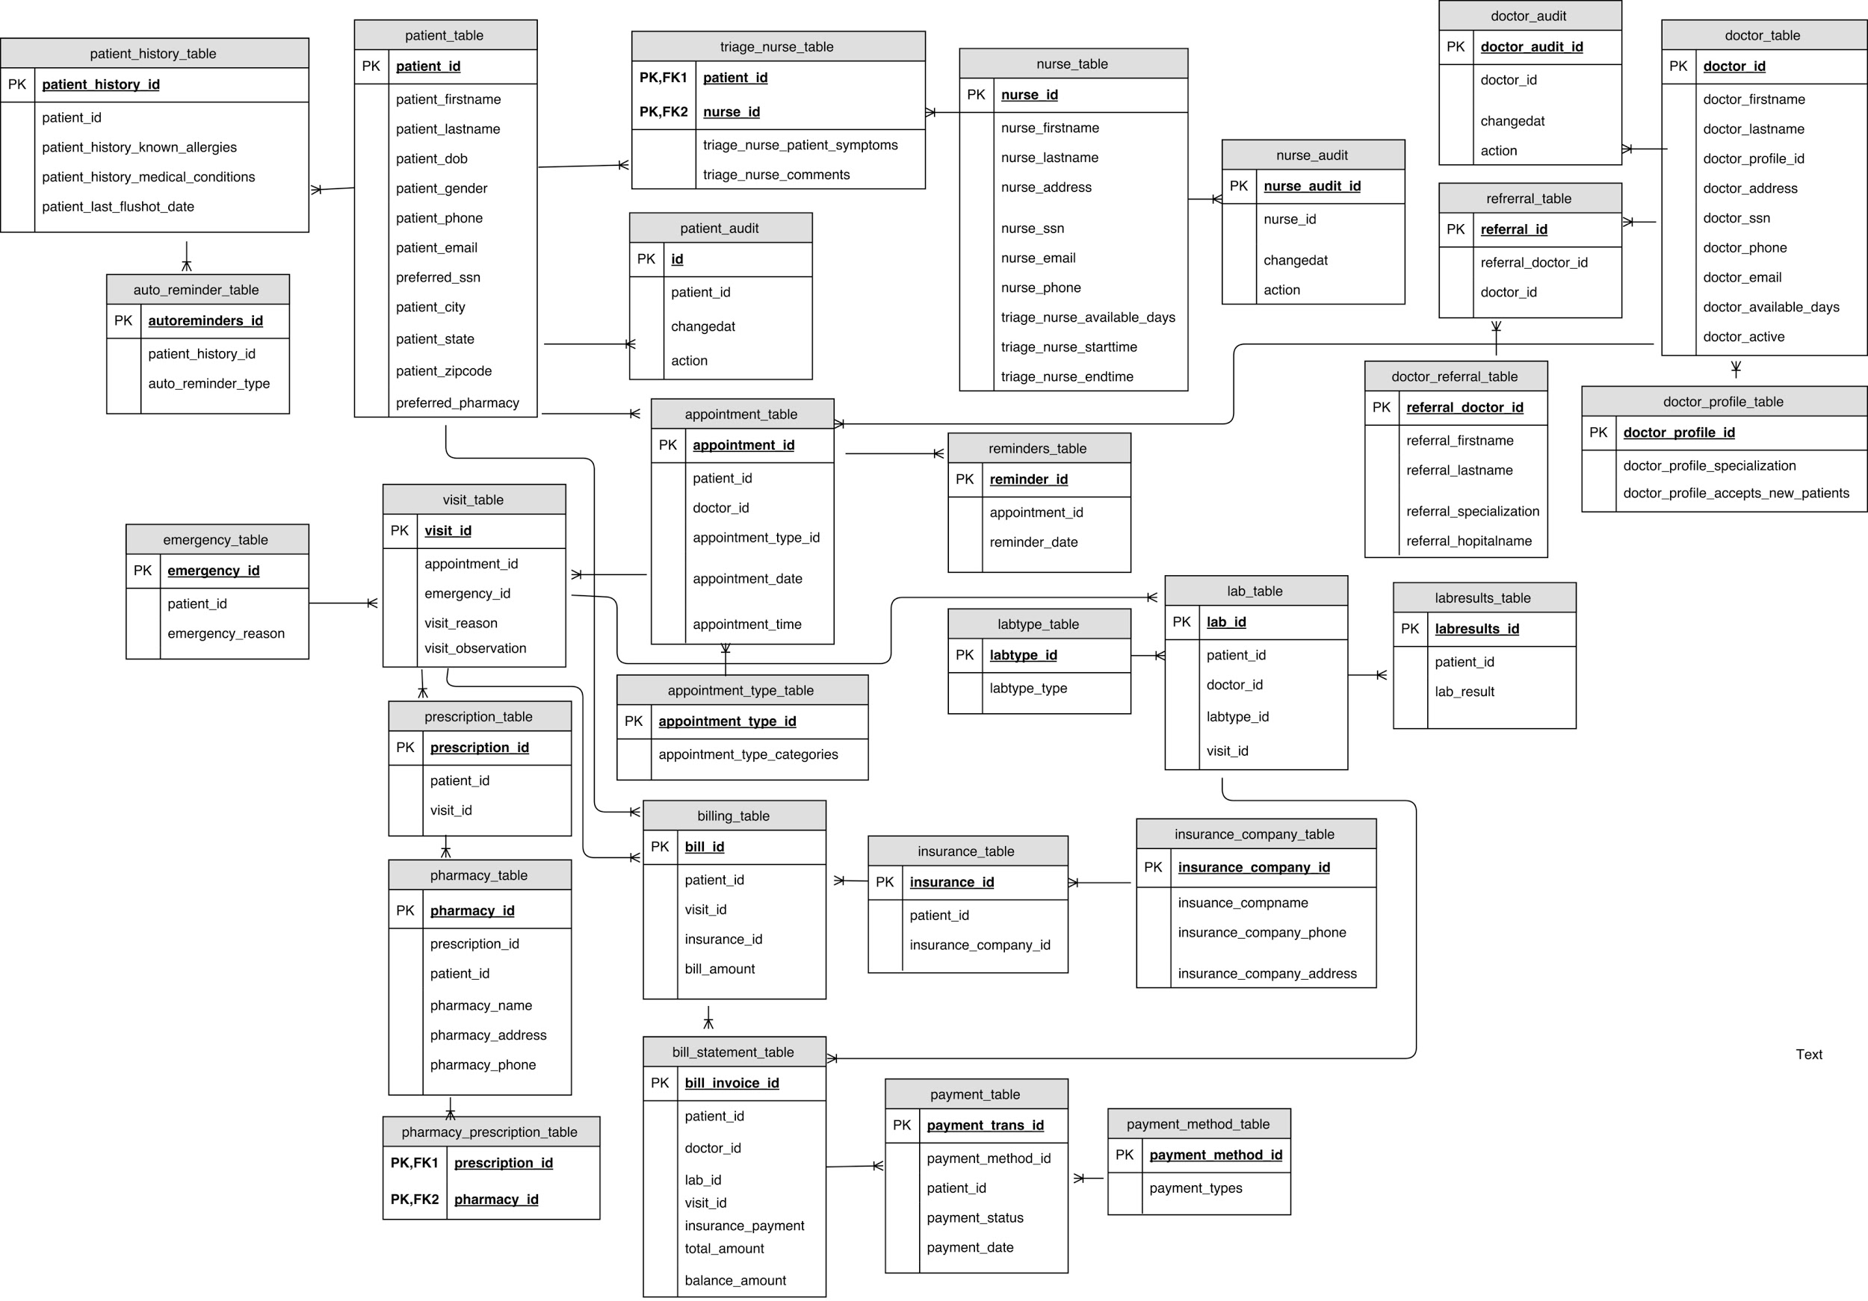

**ER Diagram:**

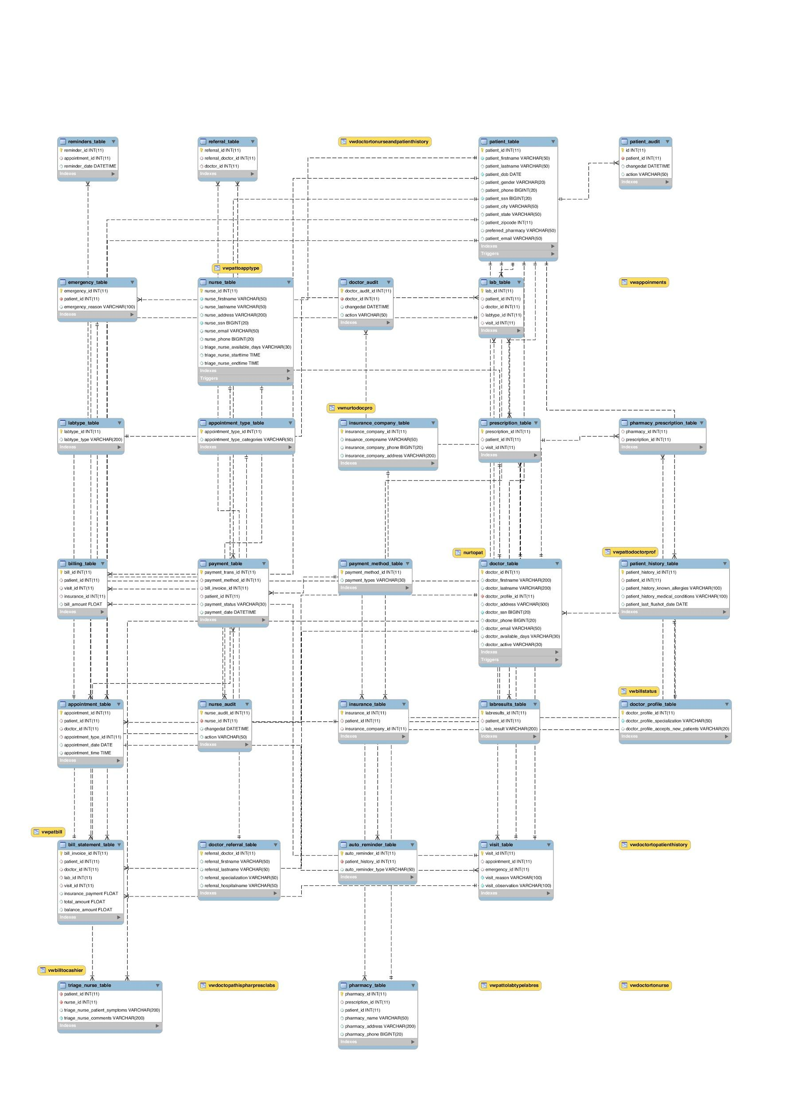

**Tables:**

patient_table, patient_history_table, nurse_table, triage_nurse_table, doctor_profile_table, doctor_table, appointment_type_table, appointment_table, auto_reminder_table, emergency_table, reminders_table, doctor_referral_table, referral_table, visit_table, insurance_company_table, insurance_table, billing_table, labtype_table, lab_table, labresults_table, prescription_table, pharmacy_table, pharmacy_prescription_table, payment_method_table, payment_table.

**Store Procedures:**

* Stored procedure to insert new patent details

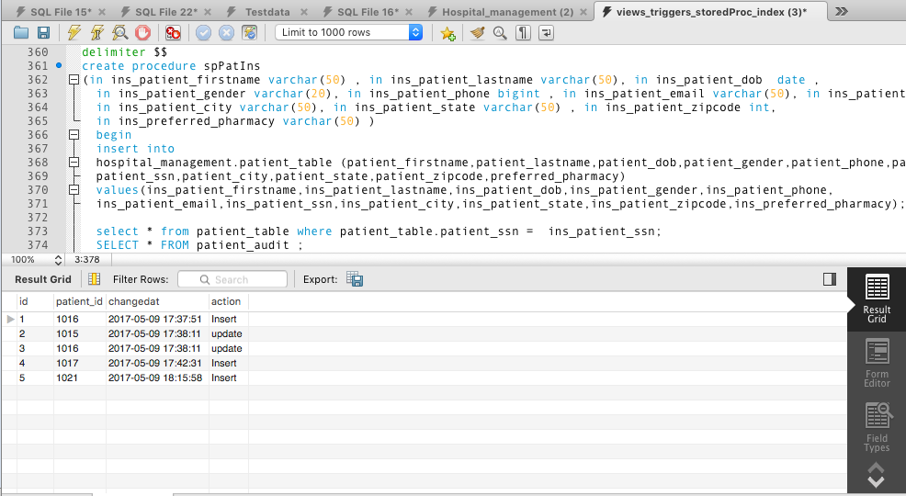

* Stored procedure for an existing user to schedule an appointment by selecting the doctor according to the doctor’s specialization

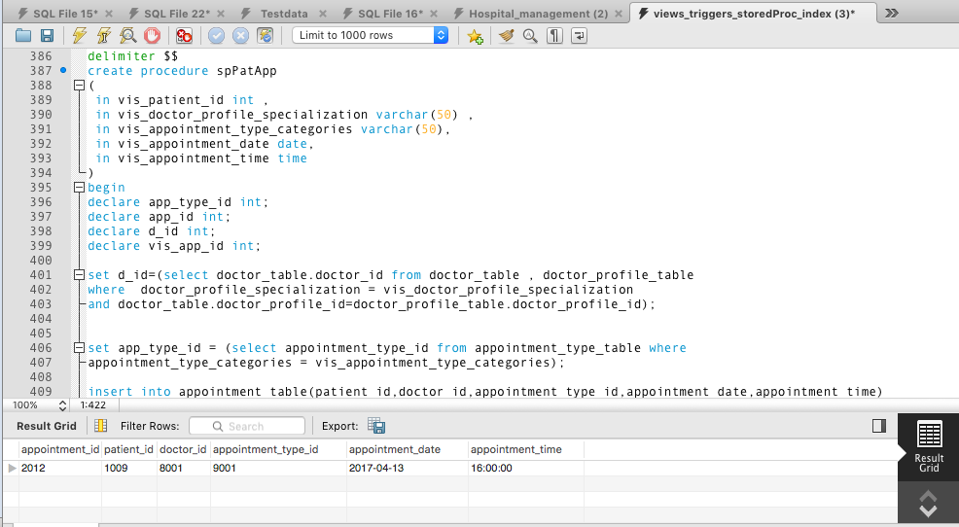

* Stored procedure where doctor would update the details of the patients who has visited.

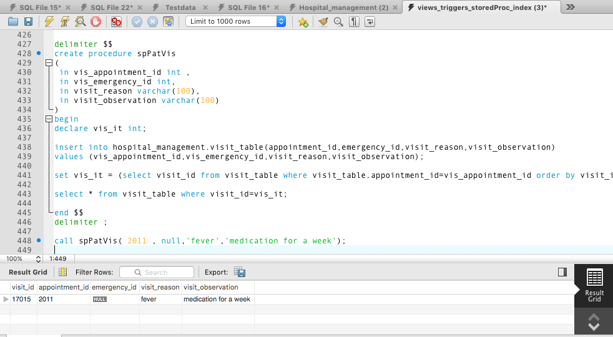

**User Authentication:**

* Doctors Authentication:

Created the doctors authentication where only the doctors could login and

view the details of the patients and the nurses.

* Hospital management admin:

This authenticator will have access to all the tables and view

* Nurses Authentication:

Created separate authentication for the nurse where she can edit the details of either the doctors or the patient’s. This is also protected by the password which only the nurse can use.

* Patients Authentication:

Created the patient authentication where patients can only view or edit the details that they can, the things like changing their address or just viewing the details of the doctor. We have restricted the actions by giving grant.

* Cashier authentication:

This authenticator will have access to only the payment tables and billing tables and will not have access to any of the tables like the doctor or the nurse.

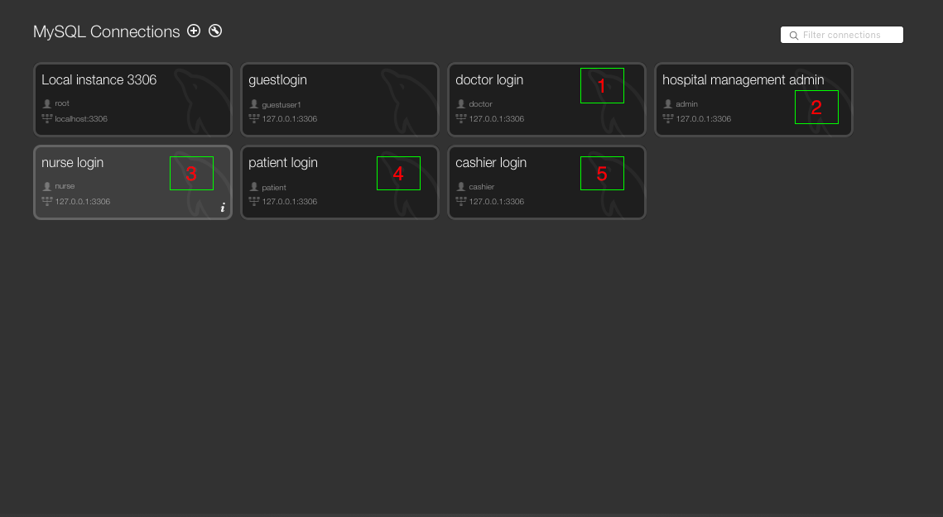

**Views:**

* Doctor to Patient:

We have created this view so that the doctor can view all the patients details at one click, so that it would save him a lot of time. Instead of writing a separate query for each and every table, we have joined queries and wrote it in a single view.

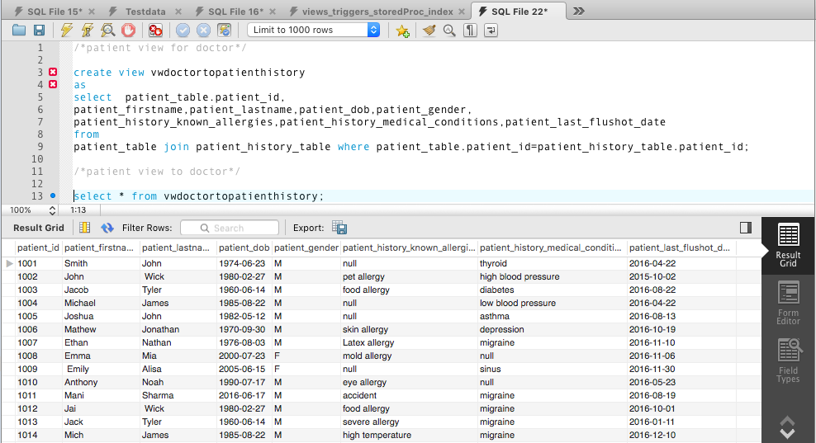

* Doctor to Nurse and patient:

This is the view where the doctor can view the nurse and also the patient details, where he can view what advices did the nurse give to the patient and also, he can check what medical problems or what allergies so the patients have.

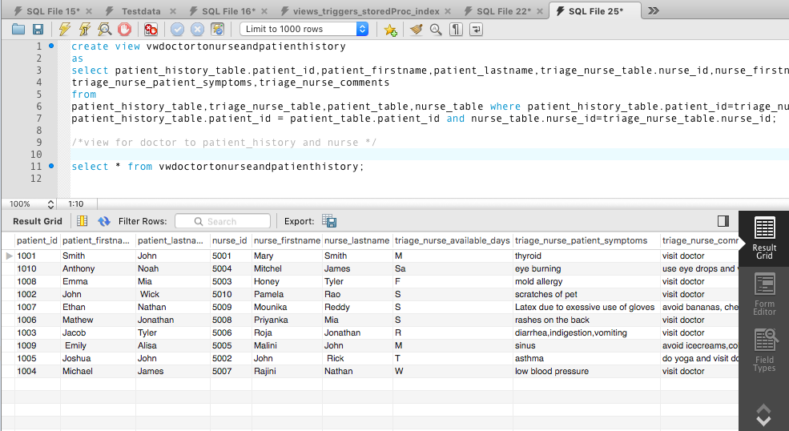

* Patient to billing view:

Here patient can view his bill where he can see how much it cost for the visits and how much the hospital has charged for the labs and how much did his insurance pay and what is the amount that he has to finally pay which will make the task easy instead of writing a query separately to check the patient's details, then check if he has undergone any lab and then check the billing table.

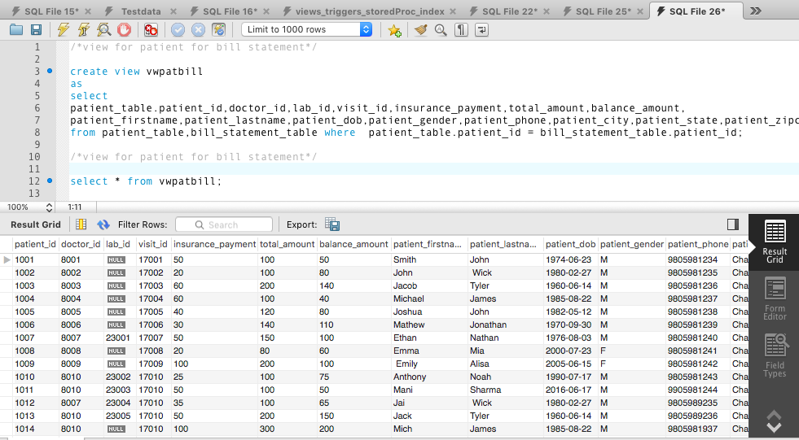

* Nurse to patients view:

Here the nurse will have access to the patient details and also the patient history based, so that when the triage nurse is suggesting a medication for the patient she should about the allergies and the medical conditions that the patient already has.

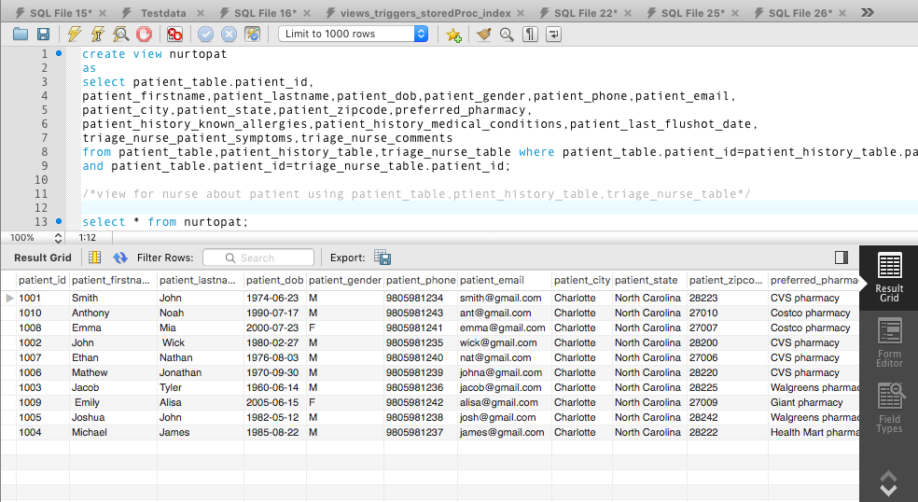

**Triggers:**

We have created triggers to get notified with the changes that are made to the data. So we have used audit tables for the patient, doctor and nurse where if a new patient is inserted in the patient table so that should get reflected in the patient audit table so that we can keep a record of all the modifications that are done to the data.

* Audit table for patient table:

We have added two triggers on insert and updates which generates row inside audit table for every respective operation.

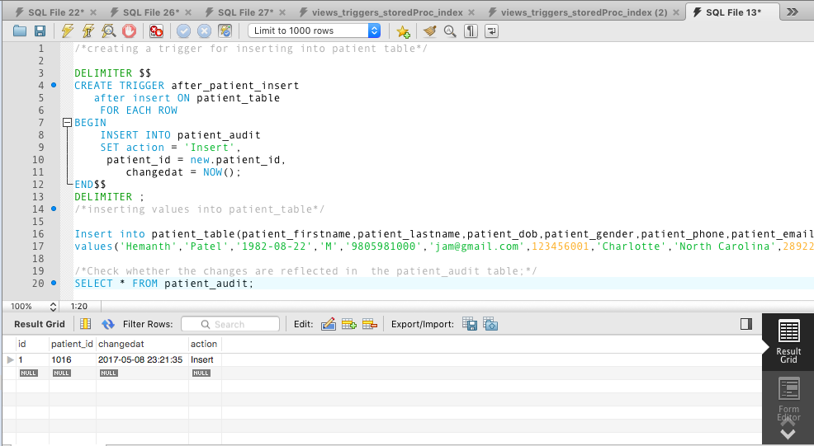

* Audit table for nurse table:

We have used this audit table for nurse so that we can keep track if some data from the nurse has been updates or deleted or inserted.

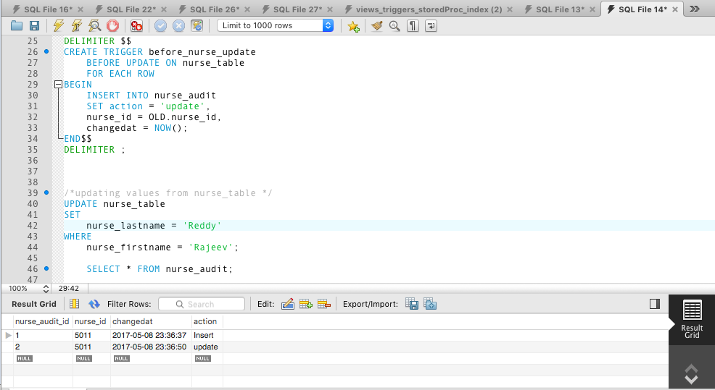

* Audit table for Doctors table:

When we have tried updating the details in the doctor's table it has been notified in the audit table.

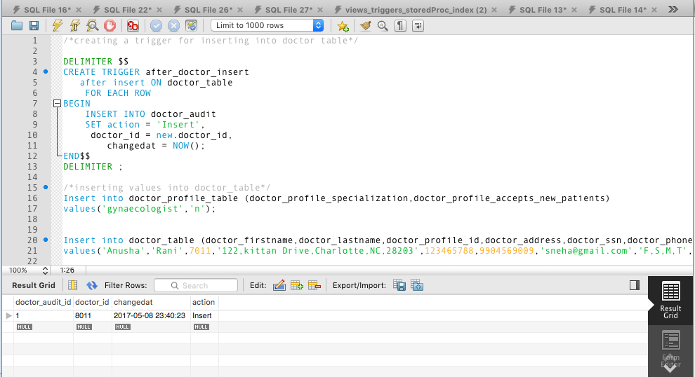

**Indexes:**

We have also added index on patients table, doctor table and appointment table to enhance the performance of the search query. Below are the screenshots where we have implemented the search query without index and with index and noticed the difference.

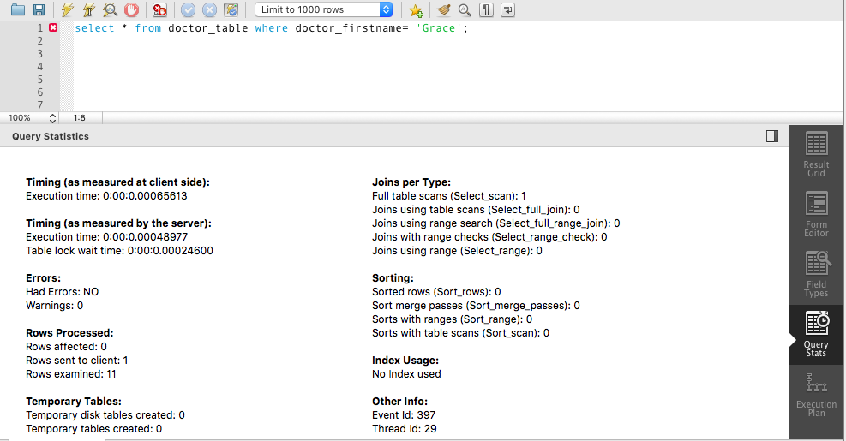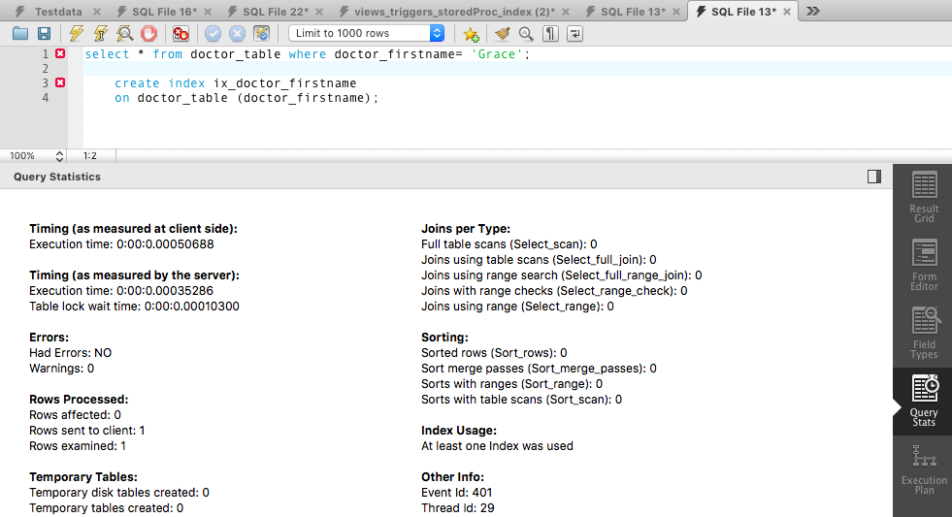

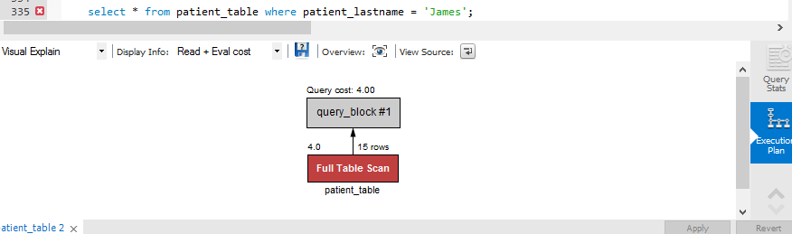

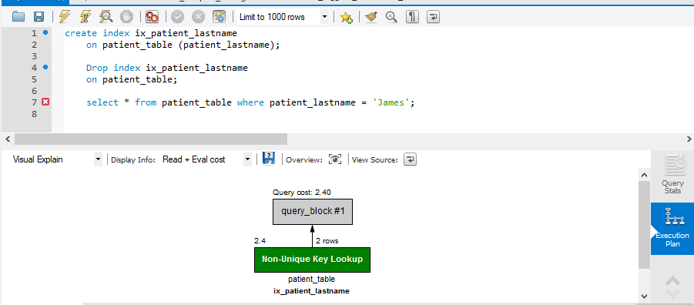

**6.CONCLUSION:**

The project Hospital Management System (HMS) is for computerizing the working in a hospital. It is a significant improvement over the manual system. The computerization of the system has speed up the process. In the current system, the front office managing is very slow. The hospital managing system was thoroughly checked and tested with dummy data and thus is found to be very reliable. The software takes care of all the requirements of an average hospital and is capable to provide easy and effective storage of information related to patients that come up to the hospital. It generates test reports and also provides the facility for viewing the details of the patient’s history by a doctor for prescribing any medicine or giving any medication. Patient can also view the doctor’s profile and his available days and time so that the patient can take an appointment. It also provides billing facility.

**7.Future Enhancements:**

* The proposed system is Hospital Management System. We can enhance this system by including more facilities like pharmacy system for the stock details of medicines in the pharmacy.
* Providing such features enable the users to include more comments into the system.
* We could include inpatient facility to our system.
* We will try and add more employees and manage their salaries.

**8.References:**

* <https://www.novanthealth.org/home/patients--visitors/locations.aspx>
* PragimTechvideos: <https://www.youtube.com/channel/UCCTVrRB5KpIiK6V2GGVsR1Q>
* Lagunita Videos: <https://lagunita.stanford.edu/dashboard>